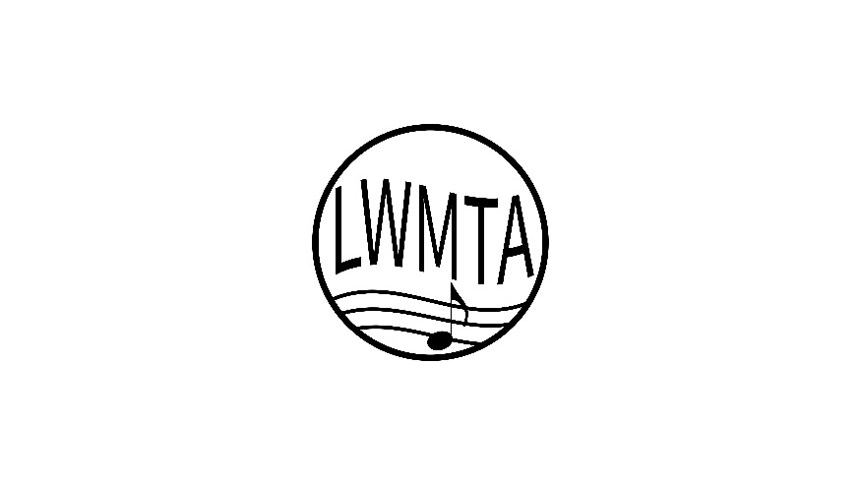
Lake Washington Music Teachers Association
Affiliate of Washington State Music Teachers Association
and Music Teachers National Association

STUDIO HONORS AWARD

In Acknowledgement of Outstanding Performance in the 2022 Musical Artistry Program

___________________________________  teacher | ____Dr. Lark Powers, NCTM  visiting artist

