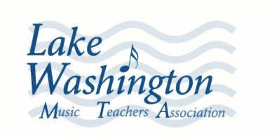
student name
performed in a Musical Gift Recital on
date
for the residents of
Overlake Terrace, Redmond Emerald Heights, Redmond Trilogy at Redmond Ridge, Redmond
Madison House, Kirkland Bellewood, Issaquah
University House, Issaquah

Your time and talent that was given for this hour
of community service is much appreciated.

Selina Chu
Musical Gift Recital Coordinator
Lake Washington Chapter, Washington Music Teachers Association

